**SYSTEM DESIGN**

**BLOCK DIAGRAM:**

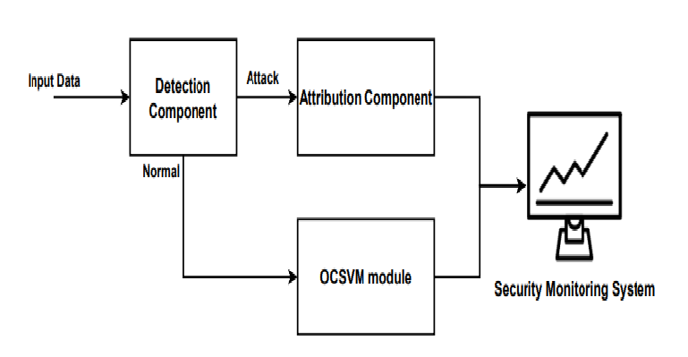

**UML DIAGRAMS**

A UML diagram is a partial graphical representation (view) of a model of a system under design, implementation, or already in existence. UML diagram contains graphical elements (symbols) - UML nodes connected with edges (also known as paths or flows) - that represent elements in the UML model of the designed system. The UML model of the system might also contain other documentation such as use cases written as templated texts. The kind of the diagram is defined by the primary graphical symbols shown on the diagram. For example, a diagram where the primary symbols in the contents area are classes is class diagram. A diagram which shows use cases and actors is use case diagram. A sequence diagram shows sequence of message exchanges between lifelines. UML specification does not preclude mixing of different kinds of diagrams, e.g. to combine structural and behavioral elements to show a state machine nested inside a use case. Consequently, the boundaries between the various kinds of diagrams are not strictly enforced. At the same time, some UML Tools do restrict set of available graphical elements which could be used when working on specific type of diagram. UML specification defines two major kinds of UML diagram: structure diagrams and behavior diagrams. Structure diagrams show the static structure of the system and its parts on different abstraction and implementation levels and how they are related to each other. The elements in a structure diagram represent the meaningful concepts of a system, and may include abstract, real world and implementation concepts. Behavior diagrams show the dynamic behavior of the objects in a system, which can be described as a series of changes to the system over time.

**USE CASE DIAGRAM**

In the Unified Modelling Language (UML), a use case diagram can summarize the details of your system's users (also known as actors) and their interactions with the system. To build one, you'll use a set of specialized symbols and connectors. An effective use case diagram can help your team discuss and represent: Scenarios in which your system or application interacts with people, organizations, or external systems. Goals that your system or application helps those entities (known as actors) achieve.

* **Use case**

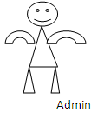 User



System

**SEQUENCE DIAGRAM**

A sequence diagram is a type of interaction diagram because it describes how and in what order a group of objects works together. These diagrams are used by software developers and business professionals to understand requirements for a new system or to document an existing process. Sequence diagrams are sometimes known as event diagrams or event scenarios.

* **Sequence Diagram**

Pre-process

user

system



Upload

User Input

Training & Testing

Modelling

Visualization

Results

* **Class Diagram :**

**System**

Data Sets and Train & Test, View Trained and Tested

X-drop, label, normal, DOS, Fuzzers, Genric, Count, X-test, Y-test

Methods

Members

**Pre-processing**

**user**

Modelling, Decision Tree, MLP, XG Boost

Entropy, precision , recall, F1-score, support, accuracy, macroavg, weightavg, true class.

Data Set, Duration, service, protocol type, Flag, submit

Csv file, dpects, rate, sload, dload, Dtype

Methods

Methods

Members

Members